Report

**Student management system Using queue**

**Eng. Mostafa Rashed Kamel Mohamed**

# Problem statement:

Write a program to build a simple software for student information management system which can perform the following operations:

1- Store the first name of the student. 2- Store the last name of the student.

3- Store the unique Roll number for every student. 4- Store the GPA of every student.

5- Store the courses registered by the student.

# Approach:

1. Add student details manually.
2. Add students’ details from text file. 3- Find student by a given roll number. 4- Find students by a given first name.

5- Find students registered in specific course. 6- Number of students registered.

7- Delete student by Roll number. 8- Update student information.

**Implementation:**

1. create structure to represent student details
2. create array of structures to act as a buffer that contains All student’s database limited by 100 records.
3. create structure to control the buffer and navigate through it using pointers and counter.
4. create functions that achieves our target
5. create Enum to represent status of each function

# Let’s see code

## Structures, Enum and buffer:

as we mentioned before

-structure to represent student object.

* Buffer to contain the whole database.
* structure to control buffer.
* Enum to represent status.

## initialization:

this function takes pointer to structure (controller buffer) and pointer to

Buffer and buffer length, then return status

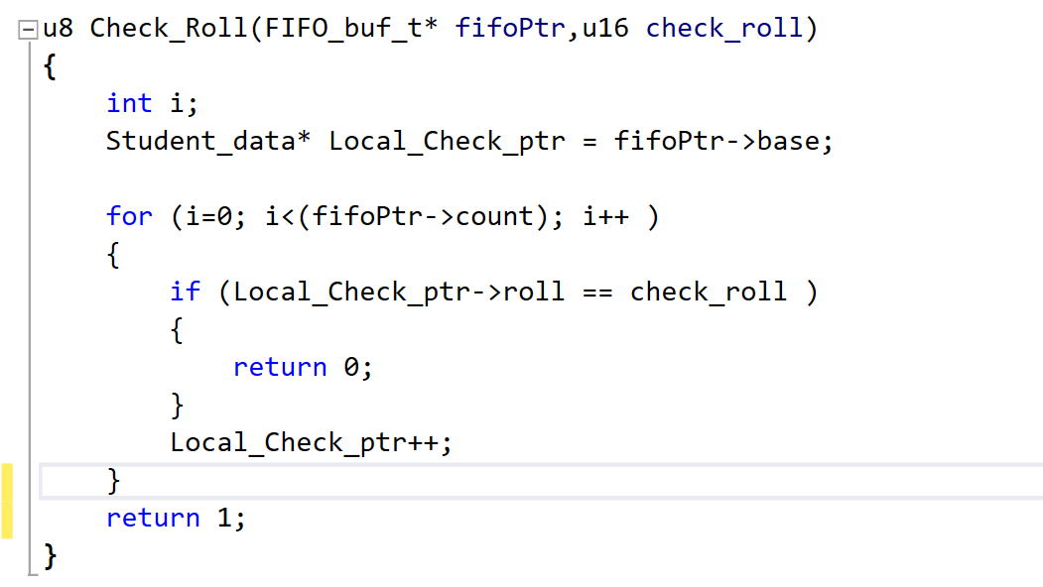-first it checks if these addresses exist or Not then adjust pointers of controller to Points to the buffer and initialize counter. **3- Check for Roll number**

this function takes pointer to buffer

controller and take integer number represents Roll number wanted to be check if exists before or not because the

roll number must be a unique number for a student.

It returns 0 if roll number found and 1 If not found.

## A screenshot of a computer program Description automatically generatedadd student manually

**-** this function to add students details manually takes pointer to

Buffer controller.

-starts with checking if the buffer is existing or not then checks if the buffer is full or not.

* 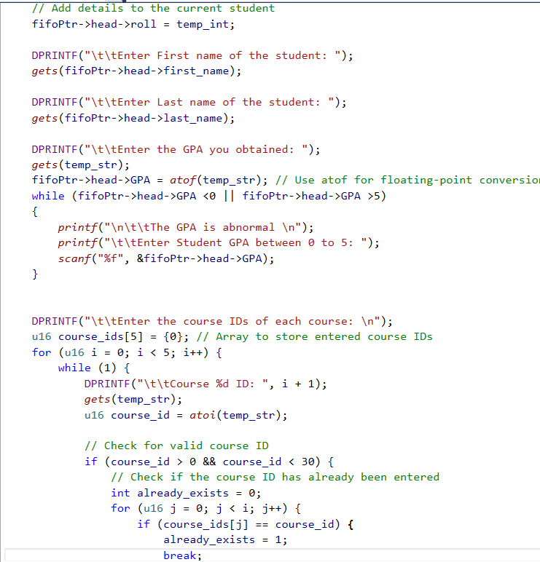then starts to take student information and check if the Roll number has been taken before or not using check_roll function.
* after that it takes another data like first name and last name and GPA
* finally, it takes the student courses that should have a valid course id, and the function will handle any non-valid course id
* 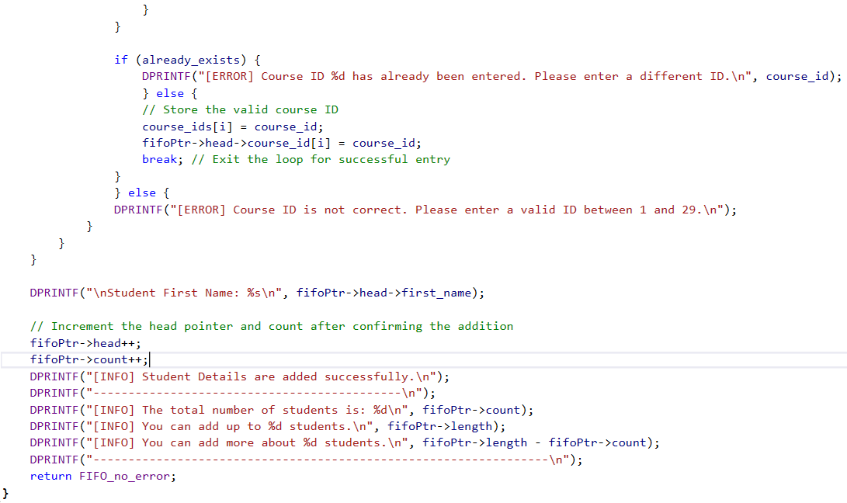if everything is going well, the function finally prints the max number of students that the buffer can hold and the number of empty places for new records.

## Show all database

* + this function responsible for display all data for all students registered.
  + It starts with checking if buffer is existing or not and check if the buffer is empty or not.
  + It loops on the buffer and extract all data
  + Finally, it informs us the total number of students

## A screenshot of a computer program Description automatically generatedfind by roll number

* + this function responsible for find the student data by roll number
  + It starts with checking if buffer is existing or not and check if the buffer is empty or not.
  + Then loop on all database to get student information by roll number.
  + If roll number is not found function will inform us.

## A screenshot of a computer program Description automatically generatedFind by first name

* + this function searches about all students that share the same student’s first name
  + It starts with checking if buffer is existing or not and check if the buffer is empty or not.
  + Then loop on all database to get student information by first name.
  + If roll the name is not found function will inform us.

## find all students registered in a specific course using course id

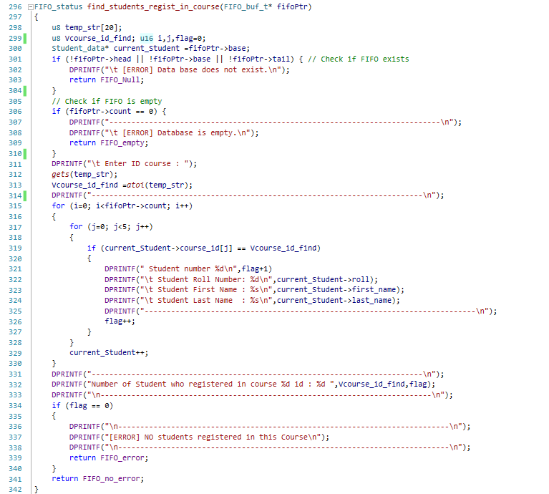-this function searches about all students that registered the same course

-we search using course id

-we loop on buffer and inside each student object we loop on courses if our course id matches any of student courses the function will print the student information.

* if the loop finished and there are no students registered this course the function will print message to inform us.

1. 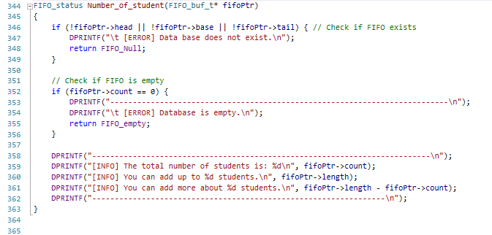**Total number of students** This function gets the total number of students in the database

## Delete student using roll number

* 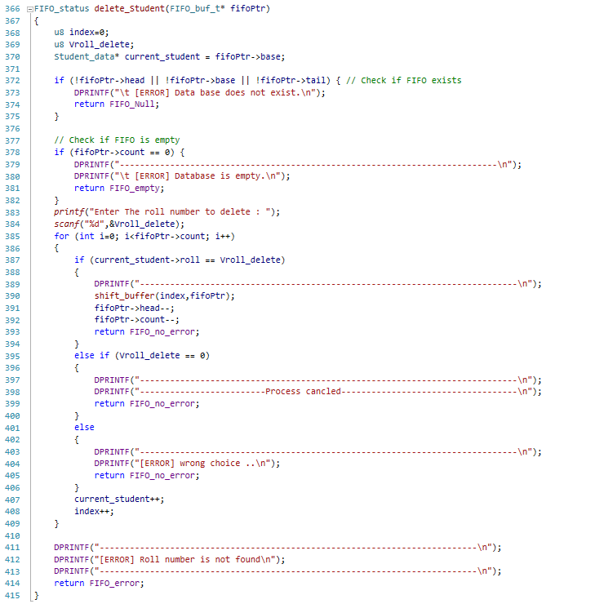this function deletes student registration by roll number.
* First it loops on database to find the roll number
* It displays student information before delete
* Then asks us to confirm deleting process
* If roll number is not found it will inform us
* If we enter wrong option It will inform and back to main menu
* This function uses another function called shift_buffer we will discuss it later.

## 11 – shift buffer

This function responsible for shifting the deleted object location and all objects after it left to fill the free location of deleted object inside the buffer.

## update student information

-this function updates a specific data in a previous registered student’s data

* this data could be first name or second name or GPA or courses.
* it navigates on database based on student roll number.
* first it displays the data of student and allow us to choose the data wanted to be updated.
* if you entered wrong choice the function will return to the main menu with a message that is wrong choice.

-if you update data of student the function will display the student’s information after updating.

-if you entered a wrong roll number it will tell you that is wrong roll number and back to main menu.

## A screenshot of a computer Description automatically generatedAdd student from text File

-this function reads from text file and save students information into data base.

-after checking buffer exist or not and is full or not the function stars connection with the text file

* it checks if roll number is taken or not and if this condition happened you get message with line error in text file and skip this record.
* A computer code with text

  Description automatically generated with medium confidenceif any student has non-valid course id, a message gets printed and this student is skipped.

-if buffer size reaches the full size The function will stop adding and

A message gets printed with the number of students added and the remaining students.

-If all things are ok a message is printed with the number of students added and the number of error in students information

1. **main function**

# Testing code logic

## 1- Adding students manually

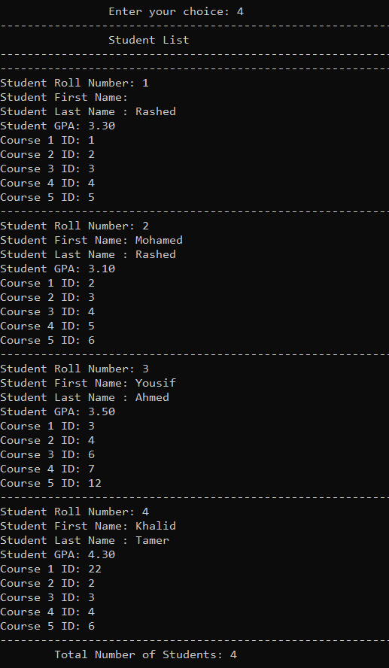We will add 4 students with the same way.

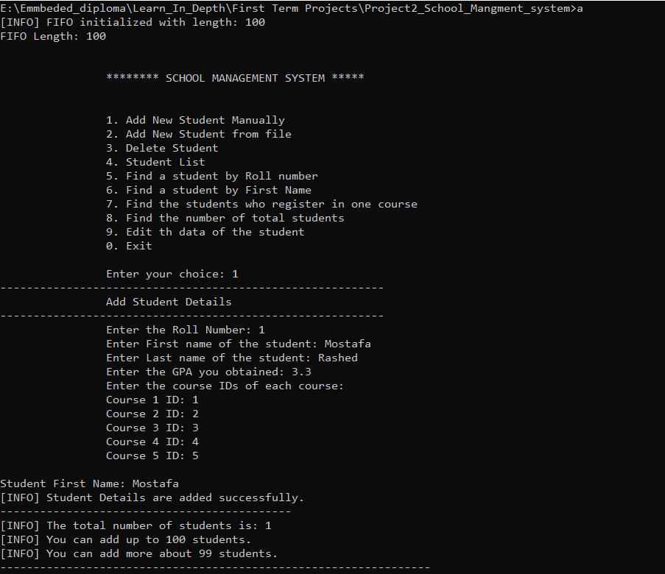

1. **Adding from text file text.txt**

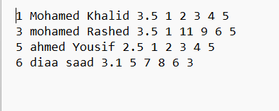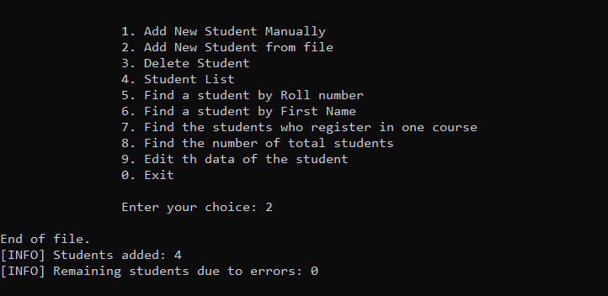

1. **get by roll number**

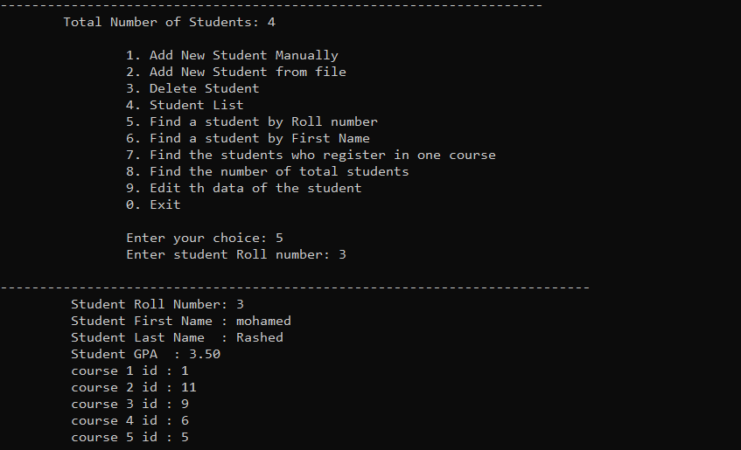

## A computer screen shot of a black screen Description automatically generatedGet all students registered in a specific course id for ex course id: 2

we have 3 students from 4 registered in course id 1

## Get total number of students

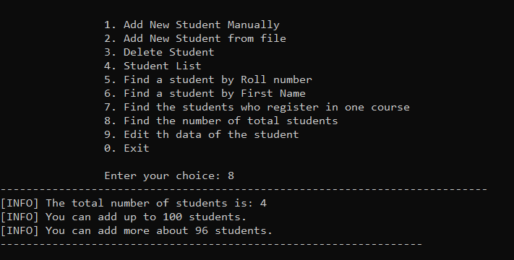

we have 4 students

## Delete student by roll number

If you enter the roll number to be delete the function displays the student information and asks you to confirm deleting process.

### Show all students after delete

## Update specific data of a student

### For example:

**update Yousif’s GPA update Yousif courses id**

